Name : Bari Aniket Prabhakar
Seat No: 704153

Assignment‌ ‌1:‌

1 . Creating database tables and using data types.
Create table , Modify table, Drop table

Synatx for Create Database:

create database database_name;

Example:

create database Collage;

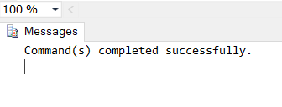
Syntax for Create table :
create table table_name (
column1 datatype,
column2 datatype,
column3 datatype,
…
);
Example :

create table student
(
id int,
Sname varchar(10),
SDOB varchar(20),
Scity varchar(10),
Sstate varchar(15),
Sbranch varchar(30)
);
select *from student;

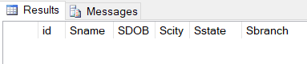

Syntax for insert data in table :
insert into table_name (column1, column2, column3, ...)
values (value1, value2, value3, ...);

Example :

insert into student values(1,'Paresh','16 Mar 1999','Mumbai','Maharashtra','MCA');
insert into student values(2,'Pravin','29 Jul 2000','Varansi','Uttar Pradesh',
'MSc CS');
insert into student values(3,'Ashwin','19 Jun 1999','Surat','Gujarat','MSc IT');
insert into student values(4,'Ninad','12 Feb 2000','Ujjain','Madhya Pradesh',
'MSc Physics');
insert into student values(5,'Saurabh','10 Jan 1998','Jalgaon','Maharashtra','MCA');

select *from student;

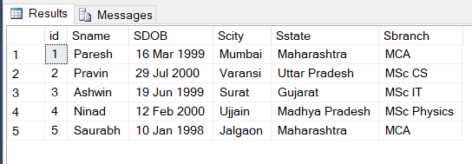

Syntax for Alter add column :
alter table table_name
add column_name datatype;
Example :

alter table student
add Scategory varchar(20);
select *from student;

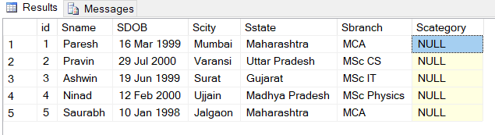
Syntax for Alter drop column :
alter table table_name
drop column column_name;
Example :

alter table student
drop column id;
select *from student;
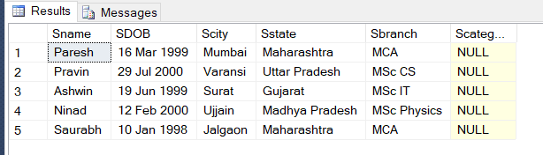

Syntax for Alter add column :
drop table table_name;

Example :

drop table student;

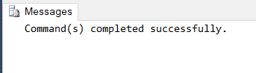

2 . Practical Based on Data Manipulation.
• Adding/Modify/Delete data using Insert/ Update/ Delete

Synatx for Create Database:

create database database_name;

Example:

create database Company;

Syntax for Create table :
create table table_name (
column1 datatype,
column2 datatype,
column3 datatype,
…
);
Example:

create table employee
(
Emp_No int,
Emp_Name varchar(20),
Emp_city varchar(20),
Emp_Id int,
Emp_Salary money,
Emp_Age int
);
select *from employee;

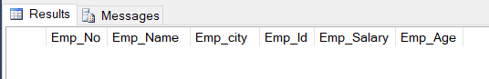

Syntax for insert data in table :
insert into table_name (column1, column2, column3, ...)
values (value1, value2, value3, ...);

Example:

insert into employee values(1,'Mahesh','Jalgaon',101,50000,22);
insert into employee values(2,'Paresh','Mumbai',102,60000,24);
insert into employee values(3,'Suresh','Pune',103,40000,21);
insert into employee values(4,'Manav','Nashik',104,30000,20);
insert into employee values(5,'Ganesh','Ujjain',105,55000,25);

select *from employee;

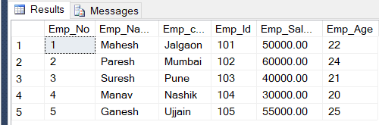
Syntax for Update table :
update table_name
set column1 = value1, column2 = value2....columnN=valueN
where [CONDITION ];

Example:

update employee
set Emp_city='Bhopal'
where Emp_Id=102;

select *from employee;

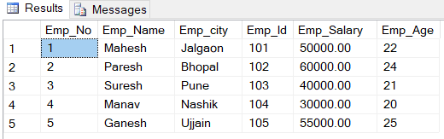

Syntax for Update table :
delete from table_name
where [CONDITION];

Example:

delete from employee
where Emp_Name='Suresh';

select *from employee;

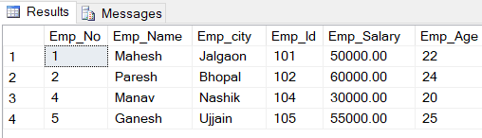

3 . Practical Based on Implementing the Constraints.
• NULL and NOT NULL, Primary Key Constraint, Foreign Key Constraint
• Unique Constraint, Check Constraint, Default Constraint

Syntax for Constraints :
create table table_name (
column1 datatype constraint,
column2 datatype constraint,
column3 datatype constraint,
…
);

Example of Not Null and
Primary Key Constraint :

create database Customer;
create table cust
(
Cust_id int primary key,
Cust_Name varchar(20) Not null,
Cust_City varchar(20)
);

insert into cust values (121,'Pranav','Pune');
insert into cust values (123,'Ankush','Mumbai');
insert into cust values (124,'Umang','Nashik');
insert into cust values (454,'Ninad','Jalgaon');
insert into cust values (575,'Harshal','Hydrabad');

select *from cust

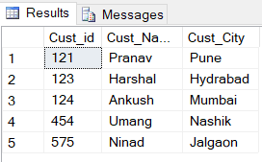

Example of Foreign Key , Unique Key ,Check Constraints
create table cust_order
(
Cust_id int check (Cust_id > 0),
Oredr_no int unique,
Item_Name varchar(20),
foreign key (Cust_id) references cust2 (Cust_id)
);

insert into cust_order values (121,21332,'Camera');
insert into cust_order values (231,32145,'Laptop');
insert into cust_order values (999,12345,'Mobile');
insert into cust_order values (124,54321,'TV');
insert into cust_order values (120,67890,'CPU');
insert into cust_order values (454,09876,'Keyboard');
insert into cust_order values (575,87609,'Fan');
insert into cust_order values (111,90876,'SSD');
insert into cust_order values (168,12895,'Bag');
insert into cust_order values (199,98634,'Shoes');
insert into cust_order values (123,19293,'Table');

select *from cust_order;

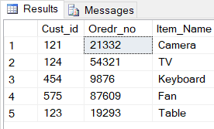

4 . Practical for Retrieving Data Using following clauses.
• Simple select clause
• Accessing specific data with Where Clause
• Ordered By/ Distinct/Group By Clause
Syntax for Select clause :
select column1,column2,columnN from table_name;

Example :
create table stud
(
stud_id int,
stud_nm varchar(20),
stud_class varchar(20),
stud_city varchar(20),
);

insert into stud values(12,'Pavan','MCA','Pune');
insert into stud values(17,'Tushar','MSc','Mumbai');
insert into stud values(14,'Jayesh','BSc','Aurangabad');
insert into stud values(52,'Vaibhav','BCA','Jalgaon');
insert into stud values(31,'Kalpesh','BE','Nashik');

select *from stud

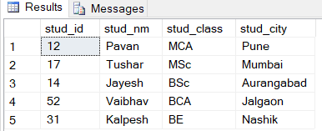

Syntax for Where clause :
select column_list from table_name;
where [condition];

Example:
select stud_nm,stud_city,stud_class from stud
where stud_id=12;
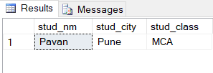

Syntax for Order By clause :
select column1, column2....columnN
from table_name where CONDITION
order by column_name {ASC|DESC};

Example:
select *from stud
order by stud_id desc;

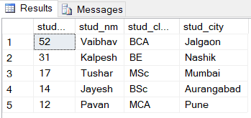

Syntax for Order By clause :
select sum(column_name)
from table_name
where CONDITION
Group by column_name;

Example:
select stud_city,sum(stud_id)
from studgroup by stud_city;

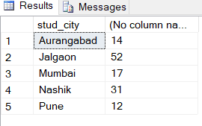
Syntax for Distinct clause :
select distinct column1, column2....columnN
form table_name;

Example:
select distinct stud_city
from stud;

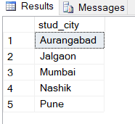

5. Practical Based on Aggregate Functions.
• AVG, COUNT, MAX, MIN, SUM, CUBE
create table products
(
pro_no int,
pro_nm varchar(10),
pro_price int,
pro_weight int
);

insert into products values (1,'Oil',20,450);
insert into products values (2,'Peanut',25,200);
insert into products values (3,'Sugar',60,400);
insert into products values (4,'Soap',40,300);
insert into products values (5,'Salt',20,250);

select *from products;

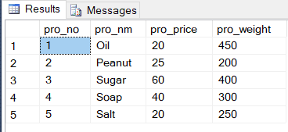

Syntax for AVG():
select AVG(“column_name”)
from table_name;

Example:

select AVG(pro_price)
from products;

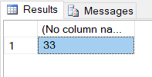

Syntax for COUNT():
select COUNT(“column_name”)
from table_name;
Example:
select COUNT(pro_weight)
from products;

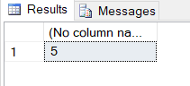

Syntax for MAX():
select MAX(“column_name”)
from table_name;

Example:
select MAX(pro_weight)
from products;

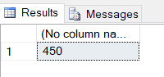

Syntax for MIN():
select MIN(“column_name”)
from table_name;

Example:
select MIN(pro_weight)
from products;

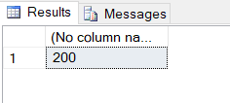
Syntax for MIN():
select SUM(“column_name”)
from table_name;

Example:
select SUM(pro_price)
from products;
